FACULTY EVALUATION
Programme Name: SBVP ALUMNI MASTERCLASS - GROW Module II Online Kenya (16th March 2026 - 20th March 2026)
Session: Review current funding of social enterprise || Identify Funding Gaps || Preparing funding plan
Faculty Name: Dr. Isaac Muiruri Gachanja
No. of Respondents: 12
No. of Participants: 12
Evaluation Parameter | (%) Individual Score | (%) Programme Average
Punctuality (Commencement and Completion of Sessions) | 97 | 98
How well do you understand the core concepts presented? | 93 | 93
Rate your confidence in applying the new skills learnt | 92 | 88
Degree of Faculty preparedness for the sessions | 98 | 98
Content and methodology of the program | 98 | 96
Quality of class and group discussions | 92 | 93
The information presented in the course is relevant to my work (ministry) | 98 | 98
Average scores | 95 | 95

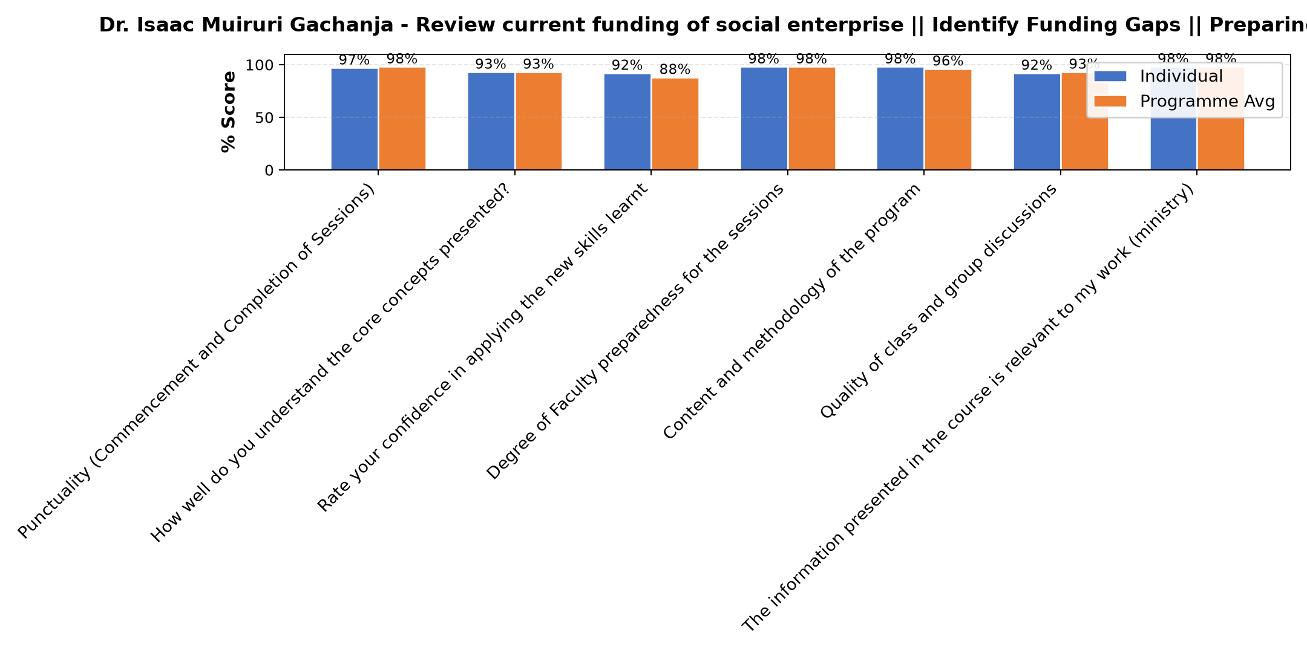

Comments & Feedback
- • Financial problems
- • Organization transition challenges
- • lack of efficient networking
- • Financial instability
- • Fear of bank loans incase i default
- • Lack of proper skills to write proposal for funding
- • Nothing
- • If I allow our enterprise remain in the valley of death.
- • All went on well
SUBMITTED THROUGH:
SBS Evaluation Automation System

